**LAB 06**

# Python for and while Loops

1. **Basic Task:** Write a for loop to print the first 10 natural numbers.

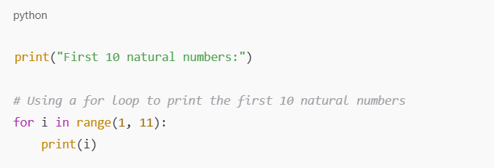

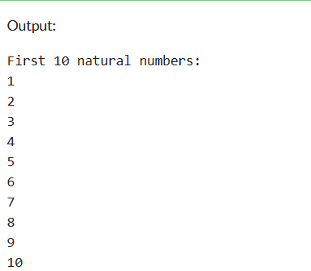

1. **Intermediate Task:** Write a while loop that prints numbers from 10 down to 1.

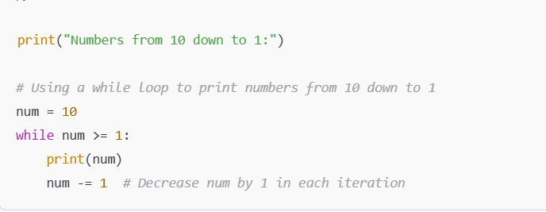

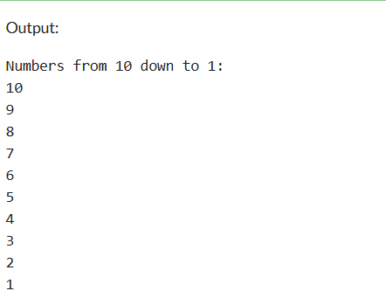

1. **Advanced Task:** Create a program that uses a for loop to iterate over a string and count the number of vowels.

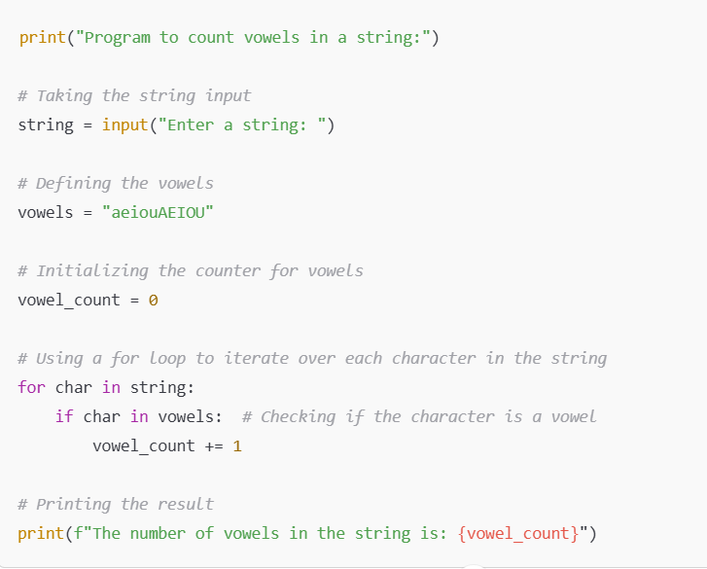

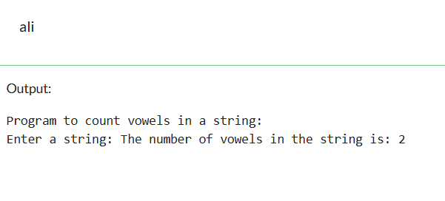

1. **Challenge Task:** Write a program that prints the Fibonacci series up to n terms using a while loop.

